Student Engagement & Opportunity
Analysis
Strategic Insights Report
SLU Opportunity Platform · Excelerate AI-Powered Data Analysis Internship

Team 2 · March – April 2026

Week 1 — Data Cleaning & Feature Engineering

Before analysis could begin, raw data required significant cleaning. Five major data quality issues were resolved and nine new features were engineered to support predictive modelling.

Data Issues Resolved:
- Mixed date formats: Custom multi-format date parser applied across 5 columns.
- 200 corrupt Apply Dates: Dates with year > 2030 set to blank and flagged downstream.
- 703 corrupt Start Dates: Set to blank with a binary flag column added.
- 3,794 missing Start Dates (44.3%): Kept as blank with a model flag for downstream use.
- Inconsistent gender & country labels: Standardised casing and labels across the dataset

9 New Features Engineered:

Feature | Type | Purpose
Age_at_Application | Numeric | Learner age at time of application
Age_Group | Categorical | Grouped age bands for segmentation
Opportunity_Duration_Days | Numeric | Length of the opportunity in days
Days_to_Apply | Numeric | Days elapsed between signup and application
Application_Year | Integer | Year of application for time-based analysis
Application_Month | Integer | Month of application for seasonal trend analysis
Is_International | Binary | Flags non-domestic learners
Is_Successful ★ | Binary (ML Target) | Primary target variable for churn prediction models
Start_Date_Missing | Binary Flag | Flags records with missing opportunity start dates

Week 2 — Exploratory Data Analysis: Key Findings

The cleaned dataset was explored visually using Python and Power BI. Four key patterns emerged that directly informed model design and platform recommendations.
Finding |  | Detail | Implication
- Applications Peak in August |  | August sees the highest volume at 1,050 applications — a clear mid-year surge that occurs every summer when students seek internships and courses during semester breaks. | The platform must scale support staff, partner slots, and infrastructure from June to handle the annual summer rush without delays.
- Age 27–30 Succeeds Most |  | Learners aged 27–30 achieve the highest success rate at 41.5%, the strongest of any age group in the dataset. | Age_Group is confirmed as a strong and reliable predictive feature for the machine learning models.
- Most Apply on Sign-Up Day |  | The median Days_to_Apply is 0 — over half of learners apply immediately after signing up. However, the average is 42 days due to a small group of learners who wait a very long time. | Learners who delay more than 30 days are at the highest risk of dropping out and should be targeted with early engagement actions.
- 7 of 9 Features Are Model-Ready |  | Only Opportunity_Duration_Days (44% missing values) and Days_to_Apply (requires a log transform) need additional preprocessing before use. | A strong feature set is immediately available for model training, reducing preparation time for future iterations.
 | Week 3 — Predictive Models & Performance

Three machine learning models were built: two to predict learner churn and one to forecast monthly application volume. Model performance is summarised below.
Model | Purpose | Accura cy | Recall | F1-Sco re | AUC | Verdict
Logistic Regression | Churn Prediction (Baseline) | 93.0% | 14.9% | 0.259 | 0.895 | - Not useful
Random Forest ■ | Churn Prediction (Best) | 95.8% | 66.0% | 0.721 | 0.926 | Recommended
Linear Regression | Volume Forecast | — | — | — | — | ■■ Needs work

Application Volume Forecast (Linear Regression):
The model forecasts application volume nearly doubling from April (505) to August (934), confirming the seasonal trend found in EDA. While RMSE (840.6) and MAPE (116.5%) indicate room for improvement, the model successfully captures the summer surge direction. A SARIMA model is recommended for higher forecast accuracy.
RMSE |  | MAE | MAPE | R²
840.6 |  | 735.3 | 116.5% | -1.152
 | Key Indicators Influencing Application Trends

- Seasonality: Applications surge every August (1,050 applications), driven by semester breaks. This is the most predictable and actionable trend in the dataset.
- Learner Age: Age group 27–30 achieves the highest success rate at 41.5%, making age a reliable predictor of outcome and a useful segmentation variable.
- Time-to-Apply: Learners who apply within 7 days of signing up are significantly more likely to succeed. Those who delay beyond 30 days are the highest churn risk group.
- Opportunity Type: Internships dominate applications at 63.3% but carry a 78.5% non-completion rate — a critical gap signalling a mismatch between learner readiness and opportunity demands.
- International Learners: 53.5% of learners are international, with USA (46.5%), India (33.1%), and Nigeria (8.9%) as the top three countries.
- Overall Success Rate: Only 38.6% of all applications result in success, with significant variation by type — Courses (99.1%) vs Internships (21.5%).

Recommendations for Future Planning

Prepare for the Summer Surge
Application volume is forecast to nearly double from April (505) to August (934). The platform should scale support staff, partner slots, and infrastructure starting June to prevent delays and learner frustration during peak demand.

Engage New Learners in the First 7 Days
Learners who delay applying by more than 7 days are at significantly higher churn risk. A simple 3-email automated sequence on Days 1, 3, and 7 post-signup can reduce dropout rates by keeping momentum high during the critical early window.

Deploy the Random Forest Model Weekly
The Random Forest model catches 66% of at-risk learners with 95.8% accuracy. Running it weekly and flagging learners above a 75% churn probability for personalised retention outreach can significantly reduce the current 8.2% churn rate.

Fix the Internship Pipeline
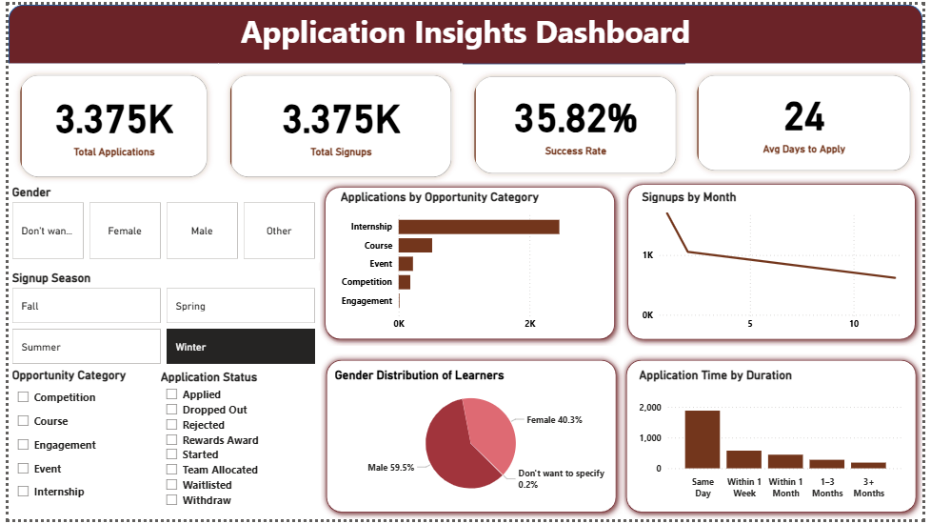
63.3% of all applications go to internships, yet 78.5% do not succeed. Requiring learners to complete a short readiness course before applying would better align learner readiness with opportunity demands and reduce rejection rates.

Here is a link to the presentation

